Thomas Redding, Ben Wedin  
  
Web App User Stories  
  
**User Story #1: Alice**  
  
Alice is putting together a presentation on poverty in the United States. As part of this presentation, she wants to include a figure comparing relative poverty rates between the fifty states. In particular, she wants to include a bar chart of poverty rates to show which states have the highest poverty rates. First, Alice arrives at our webpage.

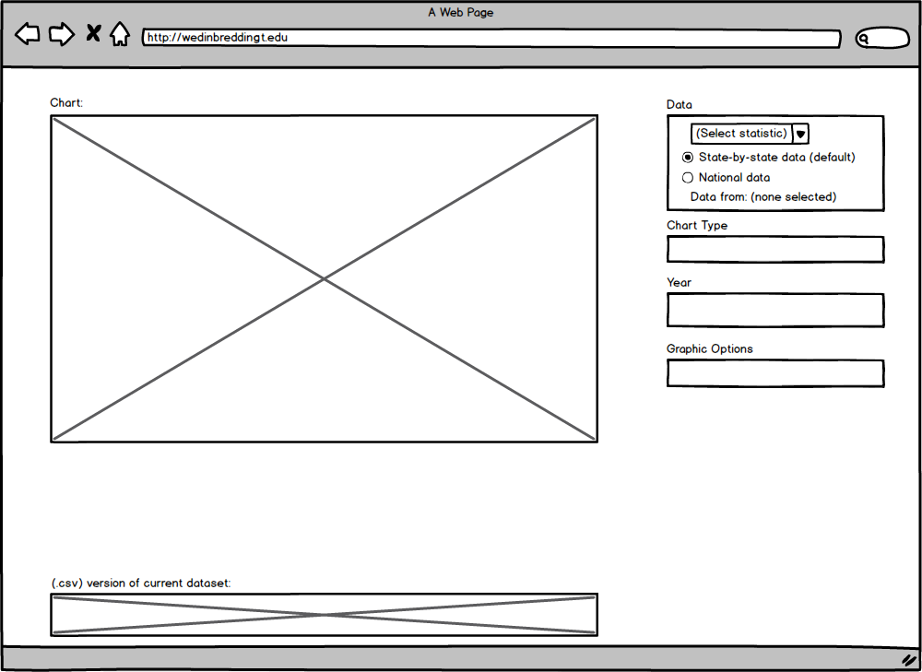

She notices a prominently displayed drop-down menu labeled “(Select statistic)” from which she selects “poverty rate”.

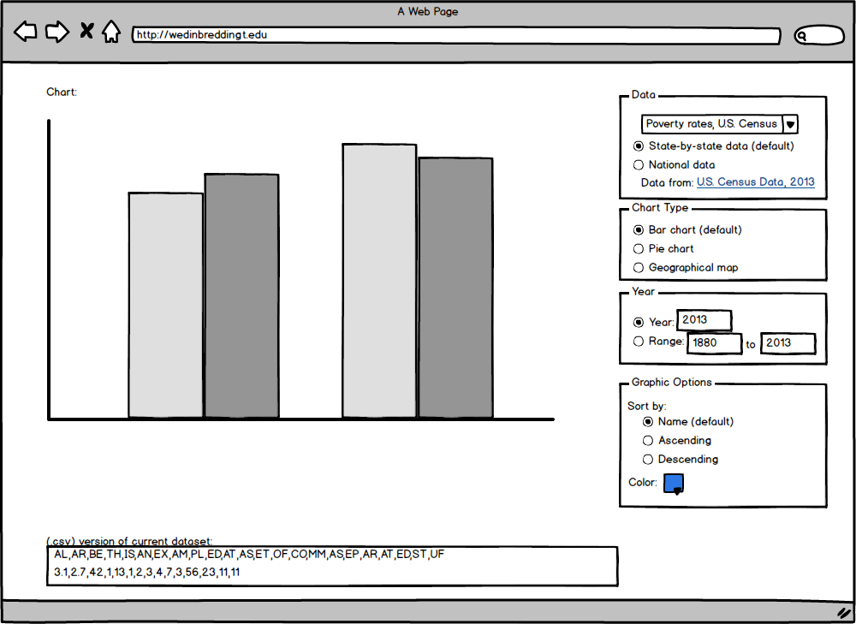

This immediately displays the poverty rate of the fifty states in a default format to give Alice immediate feedback that what she is doing is working. She notices that the chart is already a bar chart by default, so she ignores the option to change it. She notices that the color-scheme clashes with her presentation; she also notices that beneath the chart options is a color-scheme options box. She selects red. The chart updates immediately.

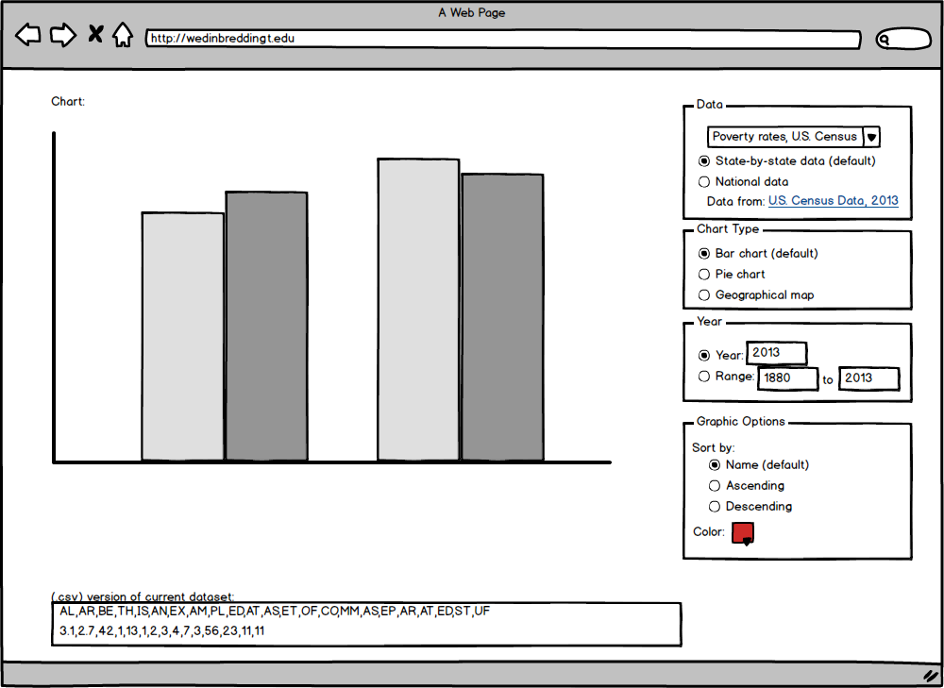

The chart data indicates that this data is form the most recent year, as Alice desires, so she leaves the time parameters unchanged. Being the savvy web-user that she is, Alice right-clicks the image and saves it to her computer. She can now insert this graphic into her powerpoint. Later, she realizes that she wants to change the color again. Fortunately, the webpage saved her latest parameter selections in a cookie, allowing her to easily update the color of the same chart.

  
  
**User Story #2: Bob**  
  
Bob is curious about how the number of arrests per year has changed over the past couple decades. In particular, he wants data to analyze for his statistics class. He arrives at our website and notices the statistic drop-down box.



He selects “arrests”. Immediately, the chart changes, but, of greater interest to Bob, the data box at the bottom of the screen immediately updates to include a state-by-state breakdown of crime data in csv format.

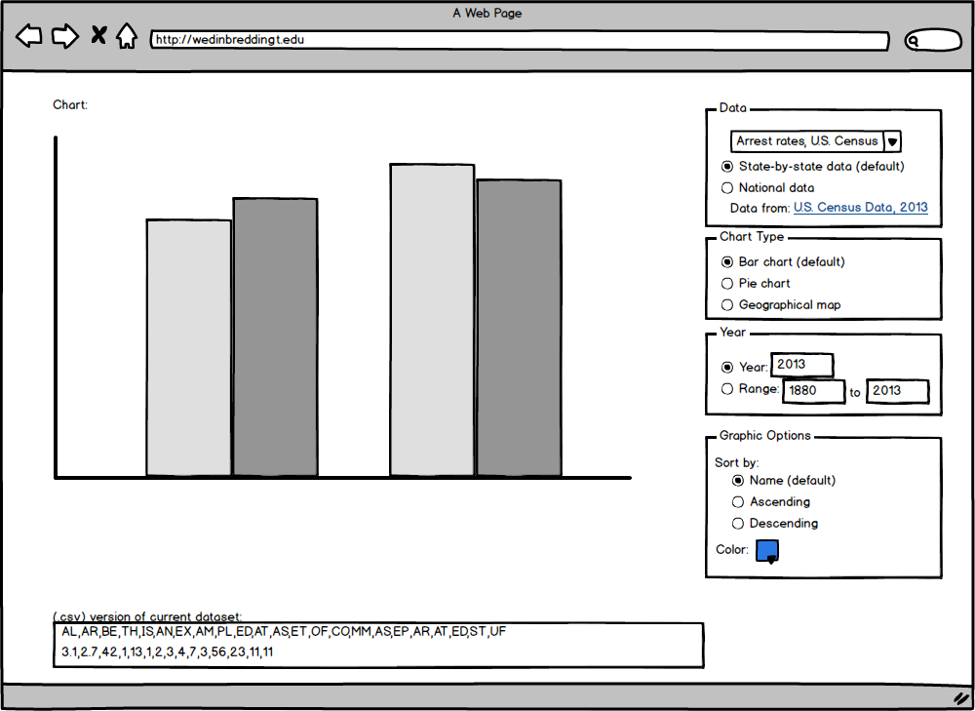

Moreover, another “div” updates with the source of the data, so Bob can cite it and doube check its accuracy. Bob, however, wants national statistics, so he selects the “national” radio button instead of the default “state” radio button.

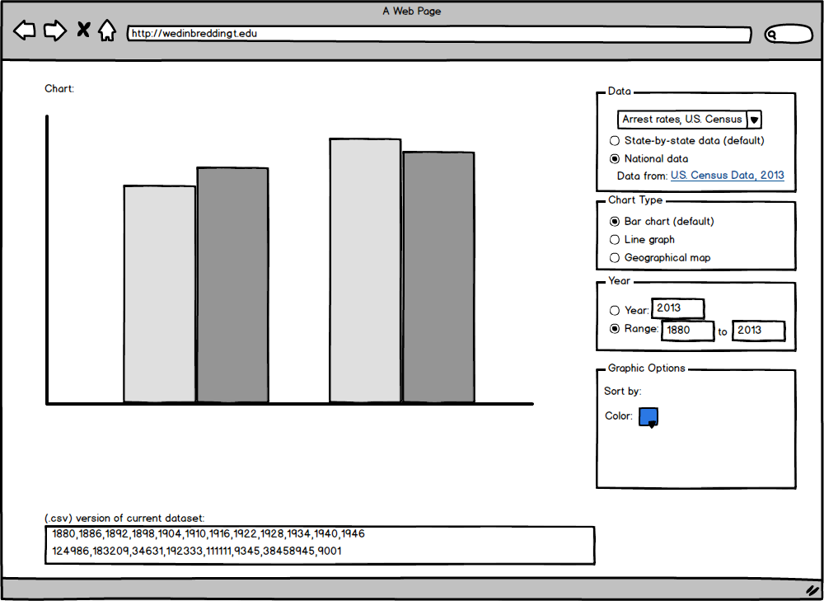

This immediately updates both the chart and the data text-box. Bob copies the data and proceeds to use for his analysis.  
  
**User Story #3: Carol**  
  
Carol is in a sociology class discussing the Great Recession and wants to know just how bad the 2009 recession was. In particular, she wants to know how its GDP growth rate differs from that of previous recessions in modern economics times (i.e. since the 1950s), and she wants a graphic for a paper she is writing. She cares neither for state-to-state breakdowns nor for statistical analysis. Carol arrives at the website.



She notices the drop-down menu and selects “GDP growth.”

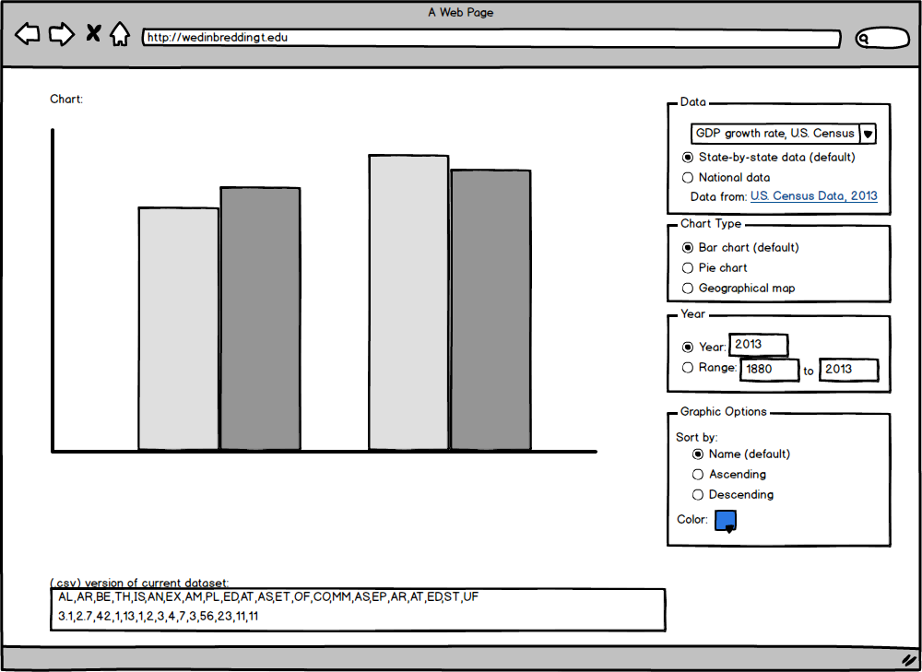

Next, she selects “national” from the radio box rather than “state”. This causes the chart to update. By default, it updates to a value-over-time chart for national statistics.

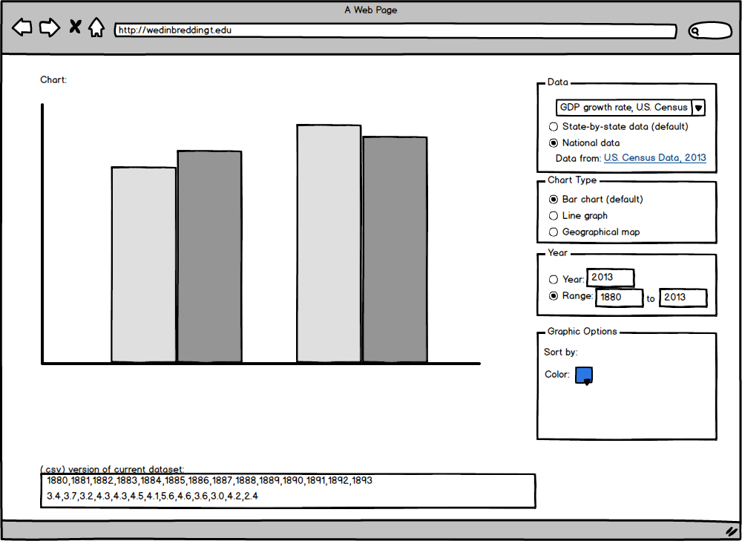

The default timespan shows all available data, but Carol only wants modern information from recent history. She notices in the “Year” box the ability to change the range of data given. Carol changes the minimum year from its default value (the earliest value for which data is available) to 1950. The chart updates immediately, and Carol’s curiosity (and requirements for one figure in her paper) is satisfied.